East Fork Professional Firefighters Association Public Relations Activity

YEAR-END CHARITABLE GIVING WRAP-UP

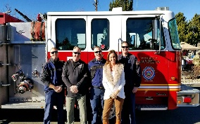
12/13/17– Record Courier: East Fork Firefighters raise more than $18,000, page 4
12/12/17- Record Courier: East Fork Firefighters raise more than $18,000
12/10/17 – Carson Now: East Fork Professional Firefighters raise over $18,000 for local families, causes in 2017
12/10/17 – Carson Now email news blast

GIVINGTUESDAY- OPERATION WARM
11/23/2017- Carson Now: East Fork Professional Firefighters Association joins the global GivingTuesday

FILL THE BOOT- OPERATION WARM
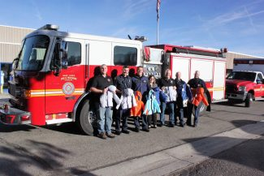
11/03/2017 – Record Courier: Valley residents collecting cash, coats, page 3

11/01/2017 – Record Courier: Valley residents collecting cash, coats

HALLOWEEN TIPS

10/29/2017 – Record Courier: East Fork firefighters offer Halloween Safety tips, front page and page 5

10/26/2017 – Record Courier: East Fork firefighters offer Halloween tips

WILDLAND / URBAN ENGINE
9/27/2017 – RC: East Fork receives grant for new wildland engine, Page 9 (Not our story)

9/21/2017 – RC: East Fork received grant for new wildland engine (Not our story)

BUSY DAY
9/20/2017 – RC: Vehicle wrecks, rescues contribute to firefighters’ busy Friday, Page 7 (Not our story)

#TRENTSTRONG
8/16/16 - Carson Valley Times: East Fork Professional Firefighters donate to #TrentStrong
8/17/17 – Record Courier: East Fork raises $700 for cancer patient

STANDARDS OF COVER
8/16/2017 – CVT: East Fork Fire Protection District Adopts 2017 Standards of Cover

7/15/17 – NAP Page A12 – East Fork firefighters asking for public’s input

7/15/17 – NAP – East Fork firefighters asking for public’s input

7/19/17 – RC page 5 – District debates plan to balance medical, fire response

7/14/17 – RC: District debates plan to balance medical, fire call response

7/14/17 – CVT: East Fork Professional Firefighters urge public to review proposed Standards of Cover

VOLUNTEER EFFORT
06/08/2017 – Record Courier: East Fork unveils new volunteer effort

NEW FIREFIGHTERS
04/15/2017 – Record Courier: East Fork Association welcomes new firefighters

04/15/2017 – Nevada Appeal: East Fork fire association welcome new members

04/18/2017 – Nevada Appeal: East Fork fire association welcome, new members, Page A4

04/19/2017 – Record Courier: East Fork Association welcomes new firefighters, Page 2

CANCER RESEARCH
3/24/2017 - Nevada Appeal: http://www.nevadaappeal.com/news/announcements/east-fork-firefighters-raise-9000-for-cancer-research/

3/24/20107 - Carson Valley Times: http://carsonvalleytimes.com/2017/03/24/east-fork-professional-firefighters-raise-9000-for-cancer-research-in-march/

3/25/2017 - Record Courier: http://www.recordcourier.com/news/local/east-fork-firefighters-raise-9000-for-cancer-research/

3/29/2017 - Nevada Appeal: Page A2

COATS
03/03/2017 – Carson Valley Times: East Fork Professional Firefighters Association Donates New Coats To Carson Valley Boys & Girls Club

03/03/2017 – Record Courier: Professional Firefighters distribute coats

RALEY’S/TEDDY BEARS
2/17/17 - Carson Valley Times: Gardnerville Raley’s, East Fork Firefighters Deliver Teddy Bears For Children Undergoing Treatment At Carson Valley Medical Center

2/17/17 - Record-Courier online: Raleys, firefighters deliver teddy bears for kids in medical treatment

