Boys & Girls Clubs of Western Nevada – Carson City
Public Relations Activity
Zet Gold
3/18/19 – Carson Now: Carson City’s Boys & Girls Clubs of Western Nevada unveils new mural by artist Zet Gold
3/19/19 – Carson Now: Email news blast – media relations, IPSM invited CarsonNow to the event
3/20/19 – Nevada Appeal – print edition pg. A10 Artists visit Boys & Girls Clubs of Western Nevada

Sweatshirts
2/25/19 – Carson Now email news blast: Boys & Girls Clubs of Western Nevada receives donation of sweatshirts, coats for members
2/25/19 - Boys & Girls Clubs of Western Nevada receives donation of sweatshirts, coats for members
Parenting Classes
11/14/18 – Carson Now: Free classes in Carson City to help with parenting, peer relationships, tough talks
11/14/18 – Carson Now email newsblast
11/14/18 – Nevada Appeal: print edition, page A15

Lights on Afterschool
10/22/2018 – Nevada Appeal: Boys and Girls Clubs celebrate ‘Lights on Afterschool’
10/22/2018 – Carson Now: Boys and Girls Clubs of Western Nevada celebrate ‘Lights on Afterschool’
10/24/2018 – Nevada Appeal: Boys and Girls Clubs celebrate ‘Lights on Afterschool’, page A14
Luau
09/26/2018- Nevada Appeal: Luau sets record for biggest event in 25-year history, Page A13
09/25/2018 – CarsonNow: Boys and Girls Clubs of Western Nevada annual luau raises highest amount in 25-year history
09/25/2018 – Nevada Appeal: Boys & Girls Clubs raises 18 percent of budget Luau

Dining Cards
08/06/2018 - Nevada Appeal: Top Stories Email
08/05/2018 - Nevada Appeal: Dining card fundraiser helps raise teen leaders in Carson City
08/04/2018 - Nevada Appeal: Dining card fundraiser helps raise teens leaders, Page A12
08/03/2018 - CarsonNow: Top Stories Email
08/02/2018 - CarsonNow: Boys and Girls Clubs of Western Nevada raising money to fund youth leadership programs

Subaru/Summer Reading
06/13/2018 – Nevada Appeal: Grants for Boys & Girls Clubs of Western Nevada reading programs
06/11/2018 - CarsonNow: Top Stories Email Blast
06/11/2018 - CarsonNow: Boys and Girls Clubs of Western Nevada awarded grants to fund annual reading programs

Kick-Off to Summer
04/29/2018 – Nevada Appeal: Kickoff to Summer, Page A4
04/28/2018 – CarsonNow: Healthy habits on display at Boys and Girls Club in Carson City

Cooking Class Mark Estee
4/30/2018 – NNBW: Lifestyle, Page 15
04/20/2018 – Nevada Appeal: Healthy Lifestyles, Page A3
04/20/2018 – CarsonNow: Top Stories Email Blast
04/19/2018 – CarsonNow: Mark Estee prepares final Carson City celebrity chef cooking class for Boys and Girls Clubs

Matt Ambassador DC Trip
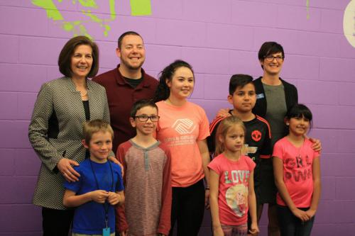
04/18/2018 – Nevada Appeal: Local Boys & Girls Clubs official heading to nation’s capital, Page A5
4/18/2018 – Nevada Appeal: Local Boys & Girls Clubs official heading to nation’s capital

4/17/2018 – Nevada Business Magazine: Boys & Girls Club’s Sampson Advocates for After School Programs in D.C.
04/16/2018 – CarsonNow: Top Stories Email
04/16/2018 – CarsonNow: Carson City’s Boys & Girls Club’s Sampson in D.C. to advocate against after school program cuts

Toyota Match
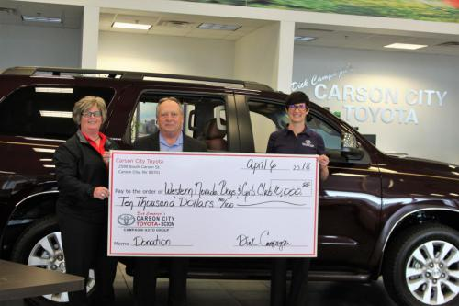
04/30/2018 – NNBW: Lifestyle, Page 15
04/23/2018 – NNBW: Briefs, Page 5
4/13/2018 – Nevada Appeal: Carson City Toyota donates $10,000 to Boys & Girls Clubs, Page A2
4/12/2018 – CarsonNow Email Blast
4/11/2018 – Nevada Appeal: Caron City Toyota donates $10,000 to Boys & Girls Clubs
4/10/2018 – CarsonNow: Carson City Toyota campaign celebrates 25 years of giving to Boys& Girls Clubs, donates $10k match to community donations

BGC Week
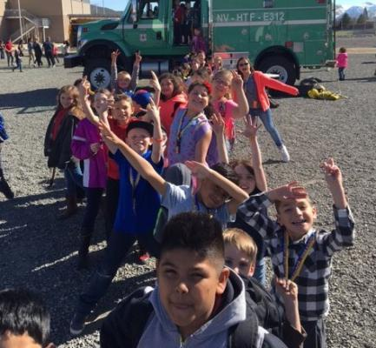
4/13/2018 – Nevada Appeal: Spring Cleaning, A4
4/13/2018 – CarsonNow: Friday fun around Carson City: Open house arts shows, nightlife, and more
4/8/2018 – NAP: Celebration set for National Boys & Girls Club Week in Carson City, Page A5
4/7/2018 – CarsonNow: Email Blast
4/7/2018 – NAP: Celebration set for National Boys & Girls Club Week
4/6/2018 – CarsonNow: Boys and Girls Clubs of Western Nevada celebrates National Boys and Girls Club Week

AmeriCorps VISTA Jon Park

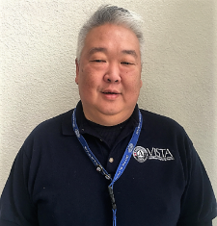
4/5/2018 – Northern Nevada Business Weekly: Jon Park named AmeriCorps VISTA Fundraising Coordinator for the Boys & Girls Clubs of Western Nevada

3/31/2018 – Nevada Appeal: Boys & Girls Clubs of Western Nevada hire fundraising coordinator, Page A3

3/30/2018 – CarsonNow: Top Stories Email Blast

3/30/2018 – CarsonNow: Boys and Girls Clubs of Western Nevada hires AmeriCorps VISTA fundraising Coordinator

3/30/2018 – Nevada Appeal: Boys & Girls Clubs of Western Nevada hire fundraising coordinator

First Day of Spring (Not Our Story)

3/30/2018- CCSD: Email Blast

3/27/2018 – Nevada Appeal: Come out swinging, Front Page

$25 for 25

3/26/2018 – Chamber of Commerce: Chamber Briefs Email

3/23/20187 – Nevada Appeal: Boys & Girls Clubs of Western Nevada kicks off $25 for 25 campaign, Page A5

3/22/2018 – Nevada Appeal: Boys & Girls Clubs of Western Nevada kicks off $25 for 25 campaign

3/21/2018 – CarsonNow: 25th Year: Boys and Girls Clubs of Western Nevada kicks off $25 for 25 campaign

Tommy Cooking Class

2/22/2018 – Nevada Appeal: Front Page

2/22/2018 – CarsonNow: Chef Tommy Linnett teaches Celebrity Chef Cooking Class at Boys & Girls Club Wednesday

2/22/2018 – CarsonNow: Top Stories Email Blast

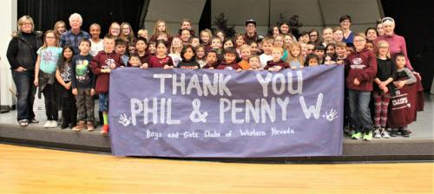
Donors/Sweatshirts
2/21/18 – Nevada Appeal: - Bursting at the seams: Boys & girls Clubs receives 850 sweatshirts, Page A3

2/18/2018 – CarsonNow: Top Stories Email Blast
2/17/2018 – CarsonNow: Busting at the seams: Boys and Girls Clubs of Western Nevada received 850 sweatshirts

Charlie Cooking Class (Not our story)

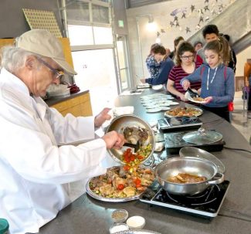
2/14/2018 – Nevada Appeal: For the love of cooking: Making room for kids in the kitchen, Page A4

2/13/2018 – Nevada Appeal: Recipe: Crunchy chicken thighs with zucchini by Charlie Abowd

Entrance Ribbon Cutting
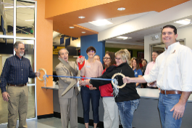
2/8/2018 – Nevada Appeal: New secure entrance opens at Boys & Girls Clubs, Front Page
2/7/2018 – Channel 2 News: http://www.ktvn.com/story/37452319/bulking-up-security-for-carsons-kids
2/7/2018 – Nevada Appeal: Boys and Girls Clubs open new entrance in Carson City
2/7/2018 – CarsonNow: Boys and Girls Clubs of Western Nevada opens news secure entrance at ribbon cutting
2/7/2018 – CarsonNow: Top Stories email blast

YOY
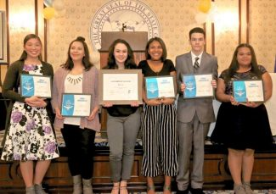
2/5/2018 – CarsonNow: Top Stories Email
2/5/2018 – CarsonNow: Boys& Girls Clubs of Western Nevada honors Youth of the Year, kicks off 25th anniversary
2/2/2018 – Nevada Appeal: Boys and Girls Clubs honors Carson City teens
2/2/2018 – Nevada Appeal: Youth of the Year, Front Page
2/2/2018 – Record-Courier: Valley Boys & Girls Clubs members honored

Cooking Class – Charlie

1/20/2018 – CarsonNow: Top Stories Email

1/20/2018 – CarsonNow: Teens learn healthy cooking habits from celebrity chefs at the Boys and Girls Club in Carson City

1/20/2018 – Nevada Appeal: Someone’s in the Kitchen, Front Page

AmeriCorps VISTA
1/4/2018 – Nevada Appeal: Boys & Girls Clubs of Western Nevada need AmierCorps VISTA volunteers and Page A3.
1/3/2018 – CarsonNow: Top Stories Email
1/3/2018 – CarsonNow: Boys and Girls Clubs of Western Nevada seeks to fill AmeriCorps VISTA positions

Giving Tuesday

11/27/2017 – CarsonNow: Top Stories Email
11/27/201711/26/2017 – CarsonNow: Boys and Girls Clubs of western Nevada joins global ‘Giving Tuesday’ movement
11/26/2017 – Record Courier: Boys & Girls Clubs joins global fundraising movement, Page 3
11/25/2017 – Nevada Appeal: Area Boys & Girls Clubs joins global fundraising movement, Page A6
11/25/2017 – Record Courier: Boys & Girls Clubs of Western Nevada joins global fundraising movement
11/24/2017 – CarsonNow: Top Stories Email
11/24/2017 – Nevada Appeal: Boys & Girls Clubs of Western Nevada joins global fundraising movement

Lowe’s Front Entrance
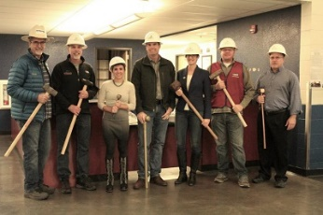
11/27/2017 – NNBW: Carson Boys & Girls Club Gets New Entryway, Page 6 Briefs
11/16/17 – Carson Now: Boys and Girls Clubs of Western Nevada break ground on new entrance, Lowe’s and local donors, partner for construction
11/16/17: NAP – New entrance to improve security at Boys & Girls Clubs
11/17/17 – NAP – front page
11/17/17 – NNBW email blast
11/17/17 – NNBW: Ground broken on new Boys & Girls Club entryway

Lights On Afterschool

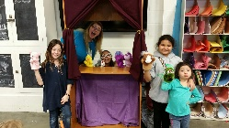
10/27/2018 – Nevada Appeal: Fun with Science, Front Page

10/26/2017 – CCSD: News Briefs 10/26/2017 Email

10/26/2017 – Nevada Appeal: Lights on Afterschool at Boys and Girls Clubs takes place Thursday and Page A3

10/26/2017 – CarsonNow: Thursday, Oct. 26: Things to do in Carson City and beyond
10/21/2017 – Nevada Appeal: 18th annual ‘Light On’ event to benefit area Boys & Girls Clubs, Page A3
10/20/2017 – CarsonNow: Boys and Girls Clubs of Western Nevada celebrates Lights On Afterschool with STEM activities and 10/23 Top Stories
10/20/2017 – NevadaAppeal: National Lights on Afterschool event to benefit Boys & Girls Clubs of Western Nevada
10/26/17 – KTVN broadcast: Boys & Girls Club helps raise awareness for afterschool programs
10/27/17 – Topix.com: Boys & Girls Club helps raise awareness for afterschool programs

Cooking Classes – David
10/19/2017 – Nevada Appeal: Stern Lecture, Front Page

Luau
10/12/2017 – CarsonNow: Boys & Girls Clubs of Western Nevada Luau nets record 17 percent of 2017 operating costs and Email Blast Top Story
10/14/2017 – Nevada Appeal: Boys & Girls Clubs fundraiser a huge success
10/15/2017 – Nevada Appeal: Boys & Girls Clubs fundraiser huge success, Page A8

Cooking Classes - Clint

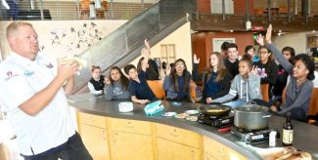
10/11/2017 – Nevada Appeal: Loco Moco is healthy recipe that hits the spot, Page A5
9/21/2017 – Nevada Appeal: Now We’re Cooking, Front Page
9/20/2017- Nevada Appeal: Celebrity chefs to work with Boys and Girls Clubs of Western Nevada

Matt Sampson / National Afterschool Alliance
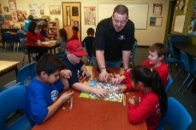
9/25/2017 – NNBW: People Section, Page 5
9/21/2017 – NNBW: People Online
9/16/2017 – Nevada Appeal: Sampson’s strength is honored nationally, Page A3
9/15/2017 – Nevada Appeal – Boys & Girls Club of Western Nevada director honored
9/15/2017 – CarsonNow – Boys & Girls director named Afterschool Ambassador for Washington policymaking efforts and their Top Stories Email

Luau
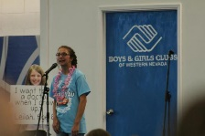
9/13/2017 – Record Courier – Thank you, Page 7
9/10/2017 – Nevada Appeal: Thank you, Page A6 and Photos, Page A7
9/5/2017 – CarsonNow: Boys & Girls Clubs of Western Nevada Luau auction items online for early bidding

Pre-K
9/4/2017 – Nevada Appeal: Caron City School District partners with Boys & Girls Clubs of Western Nevada on full day pre-K expansion project
9/5/2017 – Nevada Appeal: Mutually beneficial partnership, Front Page

6-week parenting class

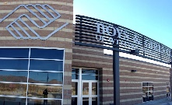
8/29/2017 – CarsonNow: Boys and Girls Clubs of Western Nevada offer free 6-week parenting clinic
8/30/2017 – Nevada Appeal: Communication, positive parenting focus of free six-week workshop
8/31/2017 – Nevada Appeal: Briefly, Free six-week parenting workshop offered, Page A2

Clubhouse
8/6/2017 – Record Courier: Funds sought for Boys & Girls Clubhouse, Page 3

8/5/2017 – Record Courier: Funds sought for Boys & Girls Clubhouse

Tice
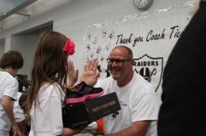
7/28/2017 – CarsonNow: Boys and Girls Clubs of Western Nevada score with Tice-Pegram Carson Valley partnership
7/28/2017 – Nevada Appeal: Boys & Girls Clubs of Western Nevada scores with TICE-Pegram partnership
7/28/2017 – Record Courier: Boys & Girls Clubs scores with Tice-Pegram partnership
7/30/2017 – Carson Valley Times: Boys & Girls Clubs of Western Nevada score with Tice-Pegram partnership
7/31/2017 – Nevada Business: Boys &Amp; Girls Clubs of Western Nevada Score with Tice-Pegram Partnership

Pre-K
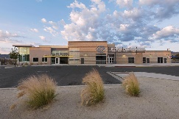
7/24/2017 - Carson Now: Carson City School District to offer preschool at Boys and Girls Club
7/24/2017 – Nevada Appeal: Carson City School District to offer preschool at Boys & Girls Clubs
7/25/2017 – Nevada Appeal: School district to offer preschool at Boys & Girls Clubs, Page A2

Summit Awards
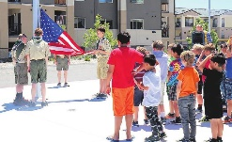
5/17/17: Nevada Appeal – Carson wins numerous Summit Awards
06/15/2017 – Nevada Appeal: Lions Club aids Boys & Girls Clubs & Page A4 (Not our story)

Battle Born
5/19/2018 – Nevada Appeal: Battle Born welcomed new expansion, Page A34
5/18/17 - Nevada Appeal: –Battle Born welcomes new expansion

Summer Programs
06/20/2017 – Nevada Appeal: Youth summer program underway in Carson City
06/20/2017 – Carson Now: Final Boys and Girls Clubs of Western Nevada summer parent orientation is June 26

Campagni Auto Group Donation
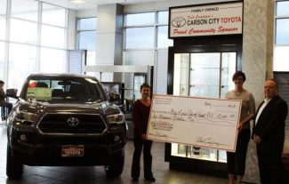
3/24/17: NAP – Campagni Matches $10k donation to B&G Clubs

Ross In-Store campaign to benefit Boys & Girls Clubs of Western Nevada
2/2/17: Carson Valley Times: Ross In-Store campaign to benefit Boys & Girls Clubs of Western Nevada
2/2/17 Carson Now: Ross clothing stores to help Carson City area kids in homework campaign
Ross Stores, Inc. announced that it is partnering with Boys and Girls Clubs of America with a four-week program called, “Help Local Kids Learn.” Beginning Saturday, Feb. 4, customers in Carson City can make a monetary contribution at their local Ross Dress for Less location during checkout to be donated to the Boys & Girls Clubs of Western Nevada this February.

Youth of the Year
1/27/17: Carson Valley Times – Boys & Girls Clubs of Western Nevada names Natalie Ontiveros…
1/27/17: Carson Now- Boys and Girls Clubs of Western Nevada names Ontiveros Youth of the Year, Tice honored
1/27/17: Record Courier- Raiders line coach honored by Boys & Girls Club

CARSON CITY, Nev. – Natalie Ontiveros, 15, was named Youth of the Year for the Boys & Girls Clubs of Western Nevada at the Clubs annual awards banquet held at the Governor’s Mansion Thursday, Jan. 26.

Western Nevada Supply
12/13/16: Nevada Business Magazine – Western Nevada Supply Brings Christmas to 251 Boys & Girls Clubs kids
CARSON CITY – Christmas came early for children across Northern Nevada, thanks to the generosity of Sparks-based plumbing and industrial distributor, Western Nevada Supply

Literacy for Life (by the Appeal)
11/9/16: Nevada Appeal – Bringing youth Literacy for Life
Servicing hundreds of students across Carson City, the Boys and Girls Clubs of Western Nevada aim to increase student success through their after school literacy program.

National Lights on Afterschool (by the Appeal)
10/22/16: Nevada Appeal – Just ‘Desserts’ in Carson City photo gallery
10/20/16: CarsonNow (IPSM forwarded NV Afterschool’s press release) – Lights On Afterschool Carson City rally at Boys & Girls Club features city and business leader
Hundreds of children, parents, business and community leaders will join the Nevada Afterschool Network today, Thursday, for a Lights On Afterschool rally at the Boys & Girls Clubs of Western Nevada in Carson City.

Buck for Kids Day (By the Appeal)
10/16/16: Nevada Appeal Business Briefs: Fundraiser benefits Boys & Girls Clubs of Western Nevada

On Thursday, Sept. 29, Dutch Bros. Carson City partnered with its community on Buck for Kids Day to raise $2,100 for the Boys & Girls Clubs of Western Nevada.

Luau
9/9/16: CarsonNow: Popular luau event to benefit Boys and Girls Club of Western Nevada returns Sunday
9/9/16: Nevada Appeal page A4
9/8/16: Nevada Appeal: MAC to help host host Luau for Boys and Girls Clubs of Western Nevada
This year’s 23rd annual Luau at the Boys & Girls Clubs of Western Nevada boasts a first in venue and improved technology for an insider’s view of the Clubs. Tickets are still available for the event from 2-7 p.m. Sunday.
8/26/16: CarsonNow: 23rd Annual Boys and Girls Club Luau Sept. 11
8/24/16: Nevada Appeal: Boys & Girls Clubs of Western Nevada holding annual luau
Young Entrepreneurs Program
7/27/16: Nevada Appeal: Carson City's young entrepreneurs providing food for thought
Social media was the buzzword of the day for local business owners receiving marketing consulting advice from teen members of the Boys & Girls Clubs of Western Nevada on Wednesday.

STEP program
8/25/16: KOLO8 Cares: Horse therapy fundraiser is Friday
7/31/16: Nevada Appeal page A9
7/27/16: Nevada Appeal: Kids, veterans connect through horses
Breathe deeply and look straight ahead. Good advice on any occasion, but on this one, it makes the difference between stopping and going.
7/27/16: KTVN Channel 2 evening segment.

McFadden Plaza Grand Opening
7/30/16: KOLO Channel 8: Carson City unveils new community plaza in downtown
7/30/16: KTVN Channel 2: New plaza in Carson City opens
Locals gathered Saturday to celebrate the opening of Bob McFadden Plaza, located on Third Street between Carson and Curry Streets in Carson City.
7/27/16: - Nevada Appeal: Bob McFadden Plaza at Third Street in Carson City opens Saturday
7/27/16 – Nevada Appeal: Front pag

Youth of the Year
7/16/16 – Nevada Appeal: Nevada State Boys & Girls Club Youth of the Year Autumn Cuellar attends national conference
7/17/16 – Nevada Appeal: Youth of the Year attends national event – Sunday, page A6
6/29/16 – CarsonNow: Carson City teen competes at Boys & Girls Clubs Youth of the Year Regional Competition
Goal number one: Ride all the rides at Disneyland, including the scary ones. Goal number two: Make friends with all of the other state Youths of the Year prior to competing against them in Anaheim for a coveted spot in the national competition in President Barack Obama’s office this fall.

Teen Center
6/23/16 – KRXI Fox 11, morning segment – New Youth center designed by teens unveiled in Carson City
6/23/16 – KRNV mynews4.com, morning segment – New Youth center designed by teens unveiled in Carson City
CARSON CITY, Nev. (News 4 & Fox 11) — A new teen center designed for teens, by teens will open in Carson City on Thursday morning.
6/23/16 – CarsonNow: Boys and Girls Clubs hosts William N. Pennington Teen Center grand opening Thursday
The Boys and Girls Clubs of Western Nevada will celebrate the ribbon cutting and grand opening of its William N. Pennington Teen Center Thursday at 10 a.m. The community is invited.
6/20/16 – RGJ: Good News: Opening of teen center set for June 23
The Boys & Girls Clubs of Western Nevada will celebrate the grand opening of its William N. Pennington Teen Center Thursday at 9 a.m., at 1870 Russell Way in Carson City
6/13/16 – Nevada Appeal: Boys & Girls Clubs of Western Nevada opens doors on teen center
6/14/16: Nevada Appeal: Front page and A4 from Media Preview Day scheduled by IPSM
6/14/16: Carson Now: Boys & Girls Clubs of Western Nevada gives a preview of new Carson City teen center
Membership is growing fast at Carson City’s new teen center.
The Boys & Girls Clubs of Western Nevada’s William N. Pennington Teen Center opened its doors last week.
Northern Nevada Business Weekly – Non-Profit profile
6/13/16 – Boys & Girls Club serving today’s youth
The Boys & Girls Clubs of Western Nevada, with five sites in Carson City and the Carson Valley, provides a safe, structured and positive environment for young people after school, during holidays and summer vacation.

Mike Tice hosting benefit
6/8/2016 – CarsonValleyTimes: Oakland Raiders Offiensive Line Coach’s Annual Dinner, Golf Tourney, Concert open to public
6/10/16 – Record Courier: Mike Tice Hosting Benefit
6/10/16 – Record Courier: Mike Tice hosting benefit, page 17-19
Oakland Raiders offensive line coach, Mike Tice, is returning on June 18-19 to host his Carson Valley friends and family golf outing benefiting the Boys & Girls Clubs of Western Nevada.

Carson Tahoe Health delivers summer fun to Boys & Girls Club
6/6/16 – Nevada Appeal: Carson Tahoe Health delivers summer fun to Boys & Girls Club
6/7/16: Nevada Appeal, page A3 right hand read above the fold
6/6/16 – Carson Now: Carson Tahoe Health delivers summer toys, sunblock to Boys and Girls Club
Each year, Carson Tahoe Health director of resource management, Kayleen Fogleman, along with the CTH holiday and special events committee, invites area children to the CTH Kids Christmas Party. This year, Fogleman is bringing Christmas in the form of summer fun toys and sunblock to the Boys & Girls Clubs of Western Nevada in June.

Summer Kick Off
4/27/16 – Carson Valley Times: Boys & Girls Clubs of Western Nevada offers parent orientation sessions through June
The Boys & Girls Clubs of Western Nevada is hosting mandatory parent orientation sessions for students registering for the summer session and the 2016-17 school year at the Carson Valley Club House located at Pau Wa Lu Middle School, 701 Long Valley Road in Gardnerville.
4/22/16 – http://carsonvalleytimes.com/2016/04/22/boys-girls-clubs-of-western-nevada-hosts-kick-off-to-summer-event/
The Boys & Girls Clubs of Western Nevada hosts its annual Kick-Off to Summer event at the Carson Valley Club House located at Pau Wa Lu Middle School, 701 Long Valley Road in Gardnerville from 10 a.m. to 2:30 p.m. Saturday, April 23.
4/24/16 Nevada Appeal: Boys & Girls Clubs to kick off summer event
Carson City Toyota Scion Community Challenge extension
4/14/16 – Nevada Appeal: Carson City Toyota Scion’s Community Challenge benefits Boys & Girls Clubs of Western Nevada
4/13/16 – CarsonNow.Org: Carson City Toyota Scion extends Boys & Girls Club Community Challenge donation drive
Dick Campagni, a long-time donor to the Boys & Girls Clubs of Western Nevada, has extended the deadline for the company’s dollar to dollar match up to $10,000 in the Campagni Toyota and Scion Community Challenge to April 30. The program was originally expected to end on April 1.

Michael Hohl Shares the Love
3/29/16 - http://www.nevadaappeal.com/news/21357752-113/michael-hohl-subaru-shares-the-love-with-boys
3/30/16 – Nevada Appeal, page A3
3/29/16 - http://www.carsonnow.org/reader-content/03/29/2016/michael-hohl-subaru-presents-donation-boys-and-girls-clubs-western-nevada-
Representatives from Michael Hohl Subaru in Carson City presented Katie Leao, chief professional officer of the Boys & Girls Clubs of Western Nevada with a check in the amount of $7,685 Tuesday, March 29, from the Subaru Share the Love event which took place from Nov 19, 2015 through Jan. 2, 2016.

Campagni Auto Group $4,000 donation
3/11/16 – CarsonNow.org: Campagni Auto Group donates $4,000 to Boys & Girls Clubs of Western Nevada
Dick Campagni presented a check for $4,000 to the Boys & Girls Clubs of Western Nevada, which provided Club-branded warm long-sleeve shirts and beanies to Club members at both the Carson City and Carson Valley locations.
3/9/16 – Carson Valley Times: Capmpagni Auto Group donates $4,000 to Byos & Girls Clubs of Western Nevada

Nevada’s Big Give
3/4/16 – Nevada Appeal: Nevada Big Give to charities March 10 – after conversation with Adam Trumble, our press release was included in a larger story about Nevada’s Big Give.

National Boys & Girls Club Week
3/4/16 – Nevada Appeal: Boys & Girls Clubs of Western Nevada to celebrate National Boys & Girls Club Week
3/4/16 – Boys & Girls Clubs of Western Nevada to celebrate National Boys 7 Girls Club Week, Nevada Appeal, page A3
3/4/16 – CarsonNow.org: Carson city celebrates National Boys & Girls Club Week with salute to heroes
3/4/16 – CarsonValleyTimes.com: Carson Valley Boys & Girls Club celebrate National Boys & Girls Club Week
The Boys & Girls Clubs of Western Nevada will open its doors to the public next week to celebrate National Boys & Girls Clubs Week, with events each evening beginning at 4 p.m. each day. The Clubs are located at 1870 Russell Way in Carson City.

Media relations
3/4/16 – Things to do in Carson City
Art showcase at the Boys & Girls Club: vote for your favorite tonight. (Featured image)

Autumn wins Youth of the Year
2/19/16 – Nevada Appeal: Carson City teen wins state title at Boys & Girls Clubs Youth of the Year competition
2/20/16 - Nevada Appeal: Carson City teen wins state title at Boys & Girls Clubs Youth of the Year competition, Page A3
2/19/16 – CarsonNow.org: Carson City teen wins state title as Boys & Girls Clubs Youth of the Year competition
Autumn Cuellar, an 18-year-old senior at Carson High School, earned the title of 2016 Nevada State Boys //& Girls Clubs Youth of the Year in Las Vegas on Thursday

Media relations
2/10/16 – Nevada Appeal page A3, Having a Ball at the MAC. IPSM promoted the story to the editor of the Nevada Appeal in January to get a story written. Online story: Boys & Girls Clubs of Western Nevada hosting basketball ball handling clinics at MAC.
2/9/15 – Nevada Appeal: Youth of the Year Winner
Senior Autumn Cuellar, 18, was named the Boys & Girls Clubs of Western Nevada 2015 Youth of the Year at the Annual Members Awards Night on Thursday. Cuellar, also the 2014 Youth of the Year, competed for the coveted title along with freshman Mackenzie Malone, 15, and freshman Natalie Ontiveros, 15.

Ross fundraiser
2/2/16 – Nevada Appeal: Ross Dress For Less donating to Boys & Girls Clubs of Western Nevada
Every year, nearly 4 million young people are served by Boys & Girls Clubs. To celebrate these extraordinary efforts, Ross Stores, Inc. announced that it is partnering with Boys & Girls Clubs of America (BGCA) with a three-week program called, “Help Local Kids Learn.” Beginning Feb. 7, Ross Dress for Less customers in Carson City can make a monetary contribution at checkout to be donated to the Boys & Girls Clubs of Western Nevada this February.

Basketball clinics at the MAC
1/29/16 – Nevada Appeal: Boys & Girls Clubs of Western Nevada hosting youth basketball clinics at Carson City MAC
1/28/16 – CarsonNow – Boys & Girls Club hosts free Saturday basketball clinics through March at Carson City MAC
The Boys & Girls Clubs of Western Nevada is hosting free basketball handling clinics for kids of all ages from 7:30 to 8:30 a.m. Saturdays through March 26 at the Multi-purpose Athletic Center, 1870 Russell Way.
PR mention – added to PR for Entrepreneurship program
1/14/16 – Nevada Appeal: Entrepreneurship program sets local youth on career and educational pathway
1/15/16 – Nevada Appeal page A6 Entrepreneurship program sets youth on career pathway (mention)
1/13/16 – CarsonNow: Entrepreneurship program sets Carson City youth on career and educational pathway
New E, sponsored by the Hop and Mae Adams Foundation, has been taught by Glass at Carson High School and the Boys & Girls Clubs of Western Nevada since February 2015. Glass will complete the New E curriculum through the end of the school year before launching Generation U.

Dutch Bros. Fundraiser
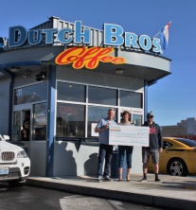
1/15/16 – Nevada Appeal: Carson City Dutch Bros. Coffee donates to Boys & Girls Clubs of Western Nevada
1/16/15 – Nevada Appeal page A4 – Coffee House Helps Area Youth
1/15/16 – CarsonNow: Dutch Bros. donates $1,300 to Boys & Girls Clubs of Western Nevada
Kurt Meyer, president of the Boys & Girls Clubs of Western Nevada board of directors, and Katie Leao, chief professional officer for the club, receive a $1,300 check from Andy Head, owner of Dutch Bros. Coffee on Carson Street, on Thursday. The coffee house pledged to donate $1 for each beverage sold on Dec. 4 to the Boys & Girls Clubs of Western Nevada.

Youth of the Year competition
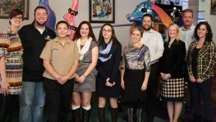
1/11/16 – Nevada Appeal: Area teens vying for Boys & Girls Clubs of Western Nevada’s Youth of the Year title
1/13/16 – Nevada Appeal page A3
1/11/16 – CarsonNow: Area teens compete in Boys & Girls Clubs of Western Nevada’s Youth of the Year competition
Family, safety and confidence were the topics of the day as three Carson City teens competed in the Boys & Girls Clubs of Western Nevada’s Youth of the Year competition on Friday.

Wiegand gift
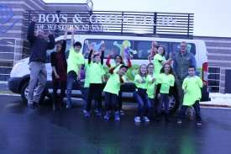
1/8/15 – CarsonNow: Boys & Girls Clubs of Western Nevada travel in style, thanks to foundation grant
1/9/16 – Nevada Appeal: Boys & Girls Clubs of Western Nevada traveling in style thanks to E.L. Wiegand Foundation grant
1/10/16 – Nevada Appeal page A3
The E. L. Wiegand Foundation presented a $70,000 grant to the Boys & Girls Clubs of Western Nevada to replace the organization’s aging vans following a visit to Carson City from Foundation President Kristen Avansino.
Adopt-a-Family

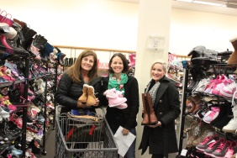
12/17/15 – CarsonNow: Local businesses partner with Boys & Girls Clubs to brighten holidays for nearly 40 families
12/18/15 – Nevada Appeal: Local businesses partner with Boys & Girls Clubs of Western Nevada to brighten the holidays for nearly 40 families
Diane McCoy, director of operations for the Boys and Girls Clubs of Western Nevada, shut the doors of the van that was overflowing with bags and cartons of gifts for the Club’s annual Adopt-a-Family Christmas drive, donated by the Ridge Tahoe EAGLES employees group.
CTH Holiday Party
12/11/15 – Nevada Appeal: Carson Tahoe Health brightens holidays of Boys & Girls Clubs of Western Nevada members
12/13/15 – Nevada Appeal page A11
12/11/15 - CarsonNow: Carson-Tahoe Health helps Santa create a happy holiday with local youth
What initially began as a holiday party for Carson Tahoe Health employees and their families has grown to include organizations like the Boys & Girls Clubs of Western Nevada through the efforts of the CTH events committee headed by Kayleen Fogleman, director of supply chain management.
Looking to the future

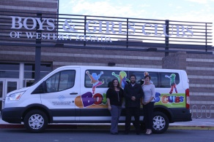
12/7/15 – Nevada Appeal: Boys & Girls Clubs of Western Nevada looks to the future
12/9/15 – Nevada Appeal page A7
CarsonNow: Boys & Girls Clubs of Western Nevada hires new director, breaks ground on teen center
The Boys & Girls Clubs of Western Nevada is aiming high for the future. The Club has brought on a new chief professional officer, turned earth on its new teen center in October and partnered with a local marketing firm to create a new website and marketing plan.

